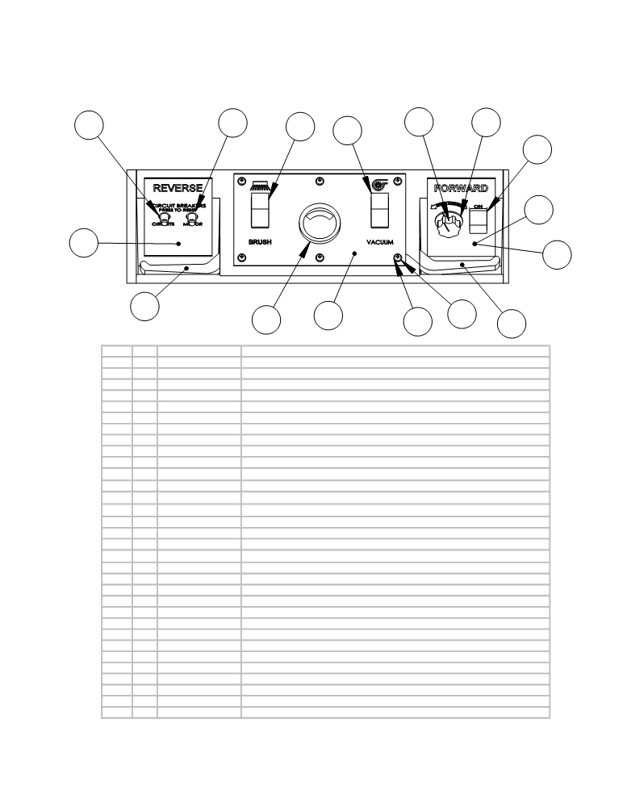

DASHBOARD LAYOUT AND
PARTS FOR DASHBOARD AND
PARTS FROM REAR VIEW OF SCRUBBER

4 5 6

7

8a 8b
9

21B

25

21T

3

29
26

2 26 28 29 1

 | ITEM | QTY. | PART NO. | DESCRIPTION
 | 1 | 1 | E11521 | RIGHT HANDLE LEVER
 | 2 | 1 | E10865 | 36 VOLT SYSTEM GAUGE
 | 3 | 1 | E11520 | LEFT HANDLE LEVER
 | 4 | 1 | E11527 | CIRCUIT BREAKER - 30AMP
 | 5 | 1 | E11528 | CIRCUIT BREAKER - 70 AMP
 | 6, 7, 9 | 3 | E11529 | ROCKER SWITCH
 | 8a | 1 | E11738 | CLAROSTAT ROTARY CONTROL
 | 8b | 1 | E11739 | SPEED CONTROL KNOB
 | 10 | 1 | E11105 | DRAIN PLUG 1 1/2 (#52003)
 | 11 | 1 | E12104 | BRUSH LIFT HANDLE
 | 12 | 1 | >> see | see "Vacuum System and Solution System" pages
 | 13 | 1 | E12110 | BRUSH LIFT HANDLE - PEDAL
 | 14 | 1 | >> see | See "Vacuum System and Solution System" pages
 | 15 | 1 | >> see | See "Vacuum System and Solution System" pages
 | 16a | 1 | E10878 | Connector, SB175, Gray, #2, w/ Lugs
 | 16b | 1 | E11889 | BRACKET FOR ANDERSON PLUG
 | 17 | 1 | E11217 | THROTTLE/ SOLUTION CABLE (for AS3200)
 | 18 | 1 | >> see | See "Brush Lift, Motor Mount, and Squeegee Lift" pages
 | 19 | 1 | E11515 | LID FLAP .062" DIA.SHEET
 | 20 | 2 | E11879 | FLAP RETAINER
 | 21B | 1 | AS26/3 | Forward Decal (for Brush Drive Scrubber)
 | 21T | 1 | E11637 | Decal, Speed Control
 | 22 | 1 | E11636 | BRUSH POSITION DECAL
 | 23 | 1 | E11878 | BACK PANEL
 | 24 | 1 | AS321532 | Flow Label NLA
 | 25 | 1 | E11634 | REVERSE DECAL
 | 26 | 1 | E11632 | DASHBOARD
 | 27 | 1 | E11635 | Decal, Squeegee
 | 28 | 14 | E11143 | 10-24 x 3/4 UNC PAN HD PHIL
 | 29 | 14 | E11508 | #10 NYLON WASHER
 | 30 | 7 | E11833 | 1/4-20x3/4 PHMS PHILLIPS - BLK
 | 31 | 7 | E11834 | 1/4 FLAT WASHER - BLACK

1 1 AS26/321301 Right Handle
2 1 AS261210 Battery Condition Meter
3 1 AS26/321300 Left Handle
4 1 AS26/321370 Circuit Breaker - 30 am p
5 1 AS26/321371 Circuit Breaker - 70 am p
6, 7, 9 3 AS26/321372 Rocker Switch (9 is for Traction Drive only)
8a 1 AS26/32850 Speed Control Potentiometer
8b 1 AS26/32851 Knob for Speed Control
10 1 AS26/321230 1-1/2" Drain Plug
11 1 AS26/321118 Brush Lift Handle Weldm ent
12 1 >> see >> for Recovery Drain Hose parts see the "Vacuum System and Solution System" pages
13 1 AS26/321127 Brush Lift Handle - Pedal
14 1 >> see >> for the Battery Drain Hose parts see the "Vacuum System and Solution System" pages
15 1 >> see >> for Vacuum Recovery Hose parts see the "Vacuum System and Solution System" pages
16a 1 AS26400 Charging Plug (Anderson plug)
16b 1 AS26/321104 Bracket for Anderson Plug
17 1 AS26601 Solution Control Cable (includes knob)
18 1 >> see >> for Sqeegee Lift Handle parts see the "Brush Lift, Motor Mount, and Squeegee Lift" pages
19 1 AS26/321275 Lid Flap
20 2 AS26/321109 Lid Flap Retainer
21B 1 AS26/321520 Forward Decal (for Brush Drive Scrubber)
21T 1 AS26/321531 Speed Control and Forward Decal (for Traction Drive Scrubber)
22 1 AS26/321530 Brush Position Decal
23 1 AS26/321102 Back Panel
24 1 AS261532 Flow Label
25 1 AS26/321500 Reverse Decal
26 1 AS26/321390 Dashboard
27 1 AS26/321510 Squeegee Decal
28 14 AS26/32352 Screw
29 14 AS26/32296 Nylon Washer
30 7 AS26/32353 Screw
31 7 AS26/32354 Flat Washer

